

Special Educational Needs/Disability (SEND) Policy

March 2024

Friday Bridge Primary School provides a welcoming, safe, happy learning environment where everyone is respected and listened to; a school where we take pride in our achievements, enabling children to become confident and successful learners. We recognise the value of each individual and provide a wealth of opportunities for children to realise their potential.
All policies are developed with children’s safety and welfare at the forefront.
This SEND policy is written to comply with the 2014 Children and Families Act and its associated regulations together with the Equality Act 2010 and follows the statutory guidance from the SEND Code of Practice 0-25 Years (2014). It relates to children with SEND.
As a school, in recent years we have experience of working with children who have the following:
- PEG feeding
- Epilepsy
- Allergies
- Vision difficulties
- Autism
- ADHD
- Medical conditions
- Neurodiveristy
- Trauma
- Specific literacy difficulties (dyslexic tendencies)
- Demand avoidance
- Dysregulation / sensory issues
- Low self esteem
- Social and emotional difficulties
- Mental Health
- Pre-verbal conditions
- Global delay
- Hyperinsulinism (blood sugar monitoring)
- Toiletting needs
- Feeding needs
- Interaction and communication

What are the aims and objectives of the SEND policy?
We will do all we can to ensure that the needs of all pupils are identified early and appropriate support provided. by:
- ensuring that early identification and necessary provision is made for any pupil who has SEND and those needs are made known to all who are likely to teach them.
- Keeping parents involved and informed of the process and decision making
- Providing an inclusive environment within school
- following the SEND Code of Practice (2014) when carrying out its duties toward all pupils with SEND
- involving the children themselves in planning for their own provision and value what they contribute through pupil voice activities (including any children who are pre-verbal)
- encouraging parental involvement with any special provision made for their child including monitoring to lead to higher rates of success
- reviewing and reporting annually on the policy and effectiveness of the school’s provision for pupils with SEND via an Information Report for Governors to keep them up-to-date and informed.
What is SEND at Friday Bridge?
Children have SEND if they have a learning difficulty which calls for special educational provision that is additional to or different from that of their age-related peers to be made for them and have completed one round of a class-teacher led Assess Plan Do Review cycle. Children have a learning difficulty if they have a significantly greater difficulty in learning than most children of the same age.
SEND is defined using four areas of need (we are aware that some pupils may have multiple or coexisting types of SEND):
- Cognition and Learning
  - Dyslexic tendencies
  - Specific literacy difficulty
  - Speech and language
  - Moderate learning difficulties
  - Dyspraxia
  - Dyscalculia
- Communication and interaction
  - ADHD
  - ASD
- Social, Emotional and Mental Health
  - Self esteem
  - Trauma
- Sensory and Physical
  - Hearing
  - Visual
  - Physical

What are the roles and responsibilities of those involved with SEND?
The ‘responsible person’ for SEN is Donna Suttle (SENCO) with Michael Elliott having overarching responsibility for the whole school and all its staff and pupils.

County-level responsibilities:
 | Responsibilities
Local Authority and other professionals | Must publish a ‘County-wide Information Hub ‘Local Offer’ which details the provision across Education, Health and Social Care that is available  Please see:  https://send.cambridgeshire.gov.uk/kb5/cambridgeshire/directory/advice.page?id=bPe2xezmLJc  Involve parents and children in the development and review of provision  Follow the framework set out in current SEND Regulations 2014  Offer an additional level of expertise and advice to school staff and parents via specialist services.  Please see:  https://www.cambslearntogether.co.uk/cambridgeshire-send/cambridgeshire-send-services/cambridgeshire-send-district-teams

School-level responsibilities:
 | Responsibilities
At Friday Bridge Primary School Governors will... | Assign a designated governor who has an oversight of the school’s arrangements for SEND who meets with the SENCO termly to consider next steps.  Publish an ‘Information Report’ detailing the school’s SEN procedures and evaluating the effectiveness of the provision provided.
At Friday Bridge Primary School the Headteacher (ME) will ... | Overall responsibility for the implementation of all policies agreed by the governing body.  Overall responsibility for school ethos (inclusive)  Ensure all extra-curricular / sporting events / trips and residential activities planned are in line with the equality act and fully inclusive.  Performance Management of the SENCO.
At Friday Bridge Primary School the SENCo (DS) will... | Designated Teacher for LAC  Oversees the day-to-day operation of the school’s SEND Policy  Co-ordinates the provision for children with SEND once the first cycle of an APDR has been completed and reviewed by class teacher.  Advises teaching staff on the graduated provision for SEN support  Quality assurance – At least once per term, SENCO will provide feedback on the quality of APDRs and annually will deliver an update training to teaching staff.  Half termly drop ins to all classes to see APDRs in practice – reasonable adjustments, does the child know targets?  Liaises with parents of pupils with SEN during the process of Early Help or Education Health and Care Needs Assessment.  Liaises with early years providers, other schools, educational psychologists, health and social care professionals etc.  Communicate with SEND service and Access and Inclusion team to minimise exclusion.  To complete paperwork associated with temporary reduced timetables.  Liaises with potential next providers of education to ensure a pupil (with an open EHA or EHCP) and their parents are informed about options and a smooth transition is planned  Works with the Headteacher and governors to ensure that the school meets its responsibilities under the Equality Act (2010) Ensures that the school keeps the records of all pupils with SEN up to date and passes information on to settings once a child leaves.  Facilitates TA training, weekly TA meetings wider staff CPD according to need including medical training annually.  Produce an annual information report.
At Friday Bridge Primary School the assistant Head (NM) will... | Arrange access arrangements for national testing for pupils with SEND (training the SENCO in this area).
At Friday Bridge Primary School the class teachers will... | Provide High Quality Teaching  Please see  https://www.haringey.gov.uk/sites/haringeygovuk/files/3_core_standard_three_-_high_quality_teaching.pdf  SENCO Handbook (NASEN)  https://nasen-prod-asset.s3.eu-west-2.amazonaws.com/s3fs-public/Teacher%20Handbook%20SEND%20-%2014th%20Dec%202021.pdf  Make reasonable adjustments at universal and targeted levels:  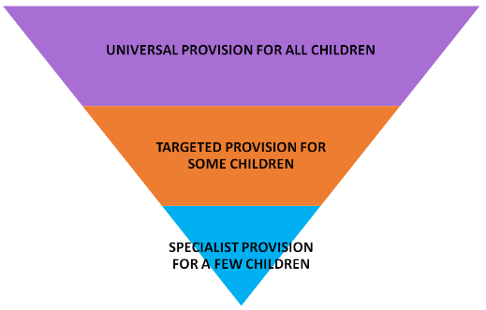  Collect and gather data and evidence on children’s achievements to facilitate the identification of children with SEN e.g. pivats,  speech and language screening, https://www.cambspborochildrenshealth.nhs.uk/services/cambridgeshire-childrens-speech-and-language-therapy-service/#professionalsection  NELI / language screening, https://oxedandassessment.com/uk/languagescreen/  ELSA referrals, https://www.elsa-support.co.uk/elsa-referral-form/  phonics and high frequency word checks,  FFT Aspire reading assessments, https://fft.org.uk/literacy/reading-assessment-programme/  Social communication descriptors, AET progression framework https://www.autismeducationtrust.org.uk/resources/progression-framework  Plan, monitor and evaluate the success of any interventions or targets set for children with SEN using the ‘assess, plan, do, review’ process following the graduated approach. The APDR should be fully informed using the Ordinarily Available Provision (OAP) Toolkit. https://www.cambslearntogether.co.uk/cambridgeshire-send/cambridgeshire-send-oap-toolkits/send-oap-toolkit  Ensure children know what they are working on (targets from APDR)  Keep parents up to date on any special provision provided for their child and discuss any concerns that have been identified – this includes sharing of APDR documents.  Liaise with the SENCo and outside agencies to seek advice on how best to support children with SEND and implement the suggestions in their classroom  Deploy support staff in order to best support pupils with SEND in line with high quality teaching and making reasonable adjustments.  Make resources for children with SEND to use.  Monitor the success of interventions – are they having a positive impact?  Undertake professional development to remain aware of current developments within SEND  Ensure all relevant staff are aware of children’s needs and the strategies that are in place to support the child.  Ensure that all records relating to children with SEND are passed on to the next teacher
At Friday Bridge Primary School our level 4 SEND teaching assistant (MW & MA) will... | Know which children are on the SEND register / have EHCP and / or vulnerable groups. Support the teacher in delivering HQT.  Remain up to date in cognition and learning, communication and interaction areas.  Support teaching staff in the “assess, plan, do, review” process.  Complete assessments – when requested to do so by SENCO e.g. PHAB 2  Promote solution focused working to solve problems.
At Friday Bridge Primary School our Intervention Lead / ELSA teaching assistant (SR) will... | Know which children are on the SEND register / have EHCP and / or vulnerable groups. Support the teacher in delivering HQT.  Remain up to date in the area of social, emotional, mental health.  Support teaching staff in the “assess, plan, do, review” process.  Complete assessments – when requested to do so by SENCO e.g. benchmarking (reading) and Sandwell (maths)  Promote solution focused working to solve problems.
At Friday Bridge Primary School our Teaching Assistants will... | Know which children are on the SEND register / have EHCP and / or vulnerable groups.  Support the teacher in delivering High Quality Teaching  Support the teacher in the ‘assess, plan, do, review’ process and carry out duties set out in the APDR, keeping a running record / evidence of review points, recording progress towards targets each time you work with the child.  Ensure children know what they are working on (targets from APDR)  Discuss with the teacher any concerns or issues raised whilst working with individuals or groups of children.  Attend meetings with outside agencies if necessary.  To participate in professional development to support both your role and whole school priorities  Where a TA has a specialism or area of expertise (e.g. Elklan trained, Dyslexia level 3) these TAs should be proactive in supporting other support staff within the school.
Parents of children with SEND will... | Work with School, Local Authority and Health and Social Care professionals to decide how best to support their child(ren)  To maintain open, honest communication with school staff and other professionals.  To actively participate in agreed measures to support their child(ren)’s social, emotional and academic development.
At Friday Bridge Primary School our pupils with SEND will... | Contribute to their own annual reviews if they have an EHCP.  Contribute to their own APDR document and one page profile with suggested strategies to help support their needs.

How is SEND assessed, identified and provided for at Friday Bridge School?
All teachers at Friday Bridge are teachers of children with SEND. Teaching of such children therefore is a whole school responsibility. The staff and governors of the school are committed to identifying and providing for the needs of all children in a wholly inclusive environment. At the heart of every classroom for every child is a continuous cycle of assessing, planning, teaching and reviewing. This takes into account the wide range of abilities, aptitudes and interests of children. As part of this process teachers will identify children whose:-
- specific or overall attainments are lower than that of their peers starting at the same baseline
- progress fails to match or better the child’s previous rate of progress
- progress fails to close the attainment gap between the pupil and their peers
- attainment gap widens between themselves and their peers
As a first response, the school will address any difficulties or barriers to learning through High Quality Teaching using the OAP toolkit and a first cycle of class teacher led APDR. For some children targeting these areas will see their learning improve. If a child continues to make less than the expected progress, the class teacher will gather further information including child voice and liaise with the SENCO to decide if the child has SEND and whether a second cycle of APDR is required. If it is decided that the child has SEN, SEN Support will begin, and the child will at this point be recorded on the SEND register.
ASSESS  Where is the child now  - Qualitative and quantitive data gathered  - Pupil voice | PLAN  What the child needs.  SMART targets  Strategies | DO  Interventions carried out consistently – up to 10 weeks, sooner if child’s needs have changed. | REVIEW  Working document – in class – TA to record as a running commentary / evidence on APDR document.  Was there TA absence?  Why didn’t the APDR make an impact?
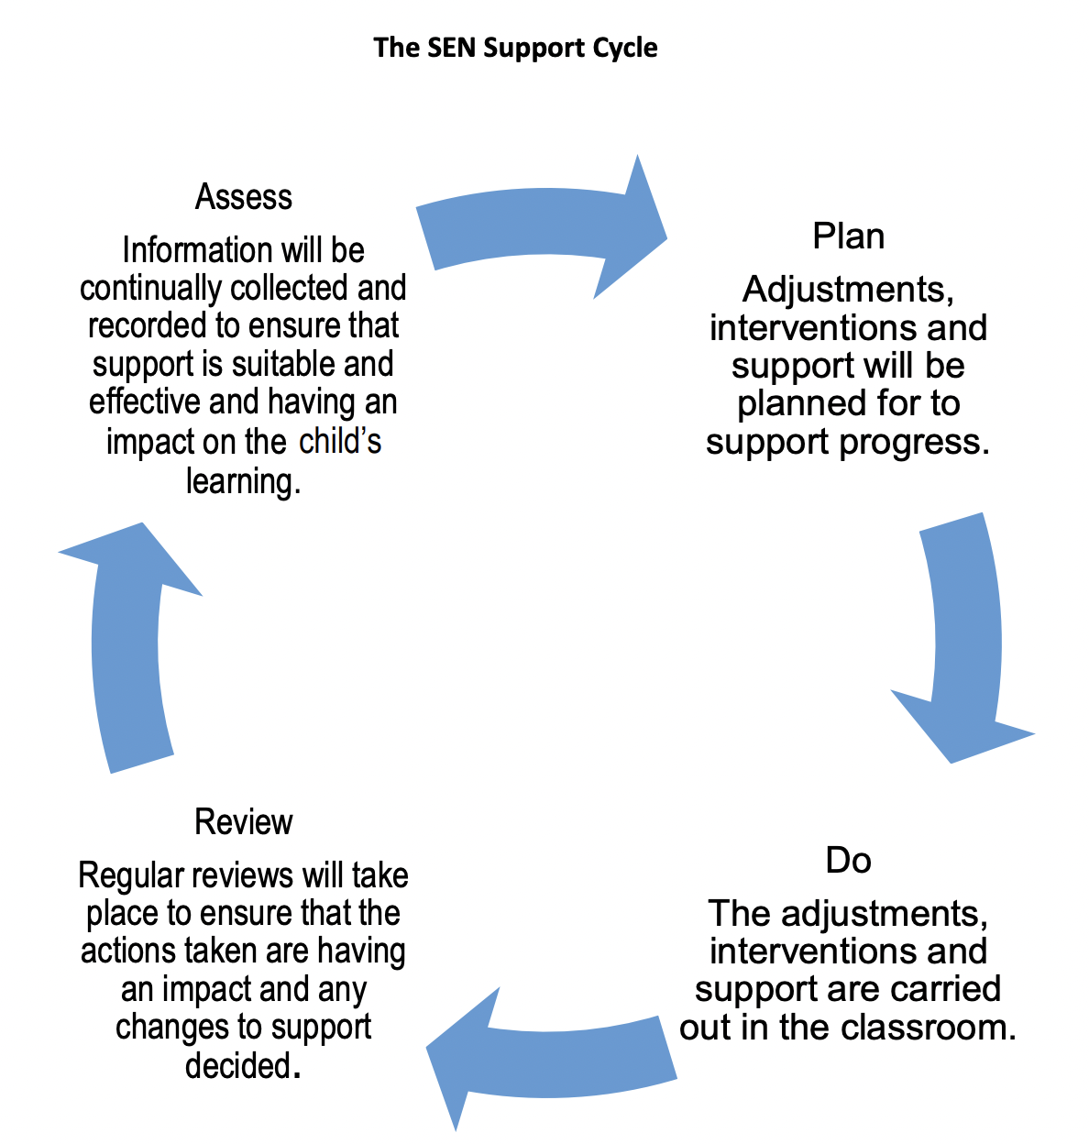

Specialist Support
For some children, it may be necessary to arrange for a specialised assessment and support from an outside agency, these may include:-
- Speech and Language Services
- Occupational Therapist Services
- Physiotherapist Services
- Services for children with hearing or vision impairments
- Child and Mental Health Services (CAMH)
- Mental Health Support Team (MHST)
- Younited (external – charity)
- ERIC (external – charity)
- Early Support
- Early Help
- SEND Service
  - Specialist teachers
  - Educational Psychologist
  - Access and Inclusion team
These assessments will help to identify the areas of need, provide advice on effective interventions and support and will form part of the Assess, Plan, Do, Review Process. If a child continues to make less than expected progress following SEN Support in school then an Education, Health and Care Plan (EHC) needs assessment can be suggested. An EHC needs assessment will help Cambridgeshire Local Authority (CLA) (or other local authority depending on child’s home postcode) decide if an EHCP should be put in place to provide provision in addition to that provided by the school. The process takes 20 weeks from the day the request is received by the CLA. Not all requests will be successful in securing an EHC however advice and next steps will always be given.
Sometimes alternative provision may be required. Please see https://www.cambslearntogether.co.uk/cambridgeshire-services-to-schools/alternative-education-provision-directory
Information on the Cambridgeshire County’s website may be found at the following link:-
https://www.cambridgeshire.gov.uk/residents/children-and-families/local-offer/local-offer-identifying-special-educational-needs-and-disabilities-0-25/send-service-0-25

Transitions to / from school / joining the school
The class teacher will assess each child’s current levels of attainment on entry and build upon the pattern of learning and experience already established. If your child already has an identified SEN, the information received from their previous school will be used by the teacher to:-
- provide starting points for the development of their learning
- identify and focus attention on how to support your child within their class
- form the basis for planning the next steps of your child’s learning
- involve you and your child in implementing a joint learning approach at home
Your child will continue to receive SEN Support in school and be part of the Assess, Plan, Do, Review Process.
What happens if English is an additional language for my child?
It is important to decide whether or not the difficulties being experienced are due to a language barrier or if your child has SEND.
What will I do if I am not happy about the decisions that are being made for my child?
The school seeks to work in partnership with parents to ensure a collaborative approach to meeting pupils’ needs. Any complaints regarding SEND provision should initially be discussed with the pupil’s Class Teacher or SENCo (if the child has an EHCP). If a satisfactory outcome cannot be agreed, the issue will then be raised with the Head Teacher. The Head Teacher will review the complaint and inform parties involved including the link Governor for Special Educational Needs.
How will we know whether the Policy is working well or not?
The Policy will be reviewed annually to ensure that it is meeting the needs of our children. Factors which will be considered during the review process will include:-
- staff awareness of procedures for assessment, identification and provision for children with SEND
- early identification of children with SEND
- partnership work with parents, children and outside agencies
- academic progress of children identified with SEND
- how staff are deployed to meet the needs of children with SEND
- the involvement of children in reviewing their SEND needs

Appendices:
- CCC Reasonable Adjustments
- Inclusive Teaching Observation Checklist
- Pupil Learning Checklist
- 5 a day principle
- SEND Code of Practice – Schools MUST checklist
- What is High Quality Teaching?

SENCO – Donna Suttle
Headteacher – Michael Elliott
SEN Governor – Geena Hird
Written: March 11 2024
Adopted: March 21 2024
Review Date: April 2025

